

**UNIVERSITY OF PETROLEUM & ENERGY STUDIES**

**Dehradun**

# Docker

**Experiment**

**Name: Harshil Bhardwaj**

**Course: B. TECH CSE DevOps (2018-22)**

**Roll no.: R171218045**

**Sapid: 500068580**

**Experiment- 6**

**Docker Linking**

Run a container in detached mode with name "db" from image "training/postgres"

$ docker run -it -d --name db training/postgres

Run another container in detached mode with name "web" from image "training/webapp", link container "db" with alias "mydb" to this container and finally pass an inline command "python app.py" while running container.

$ docker run -it -d -–name web -–link db:mydb training/webapp

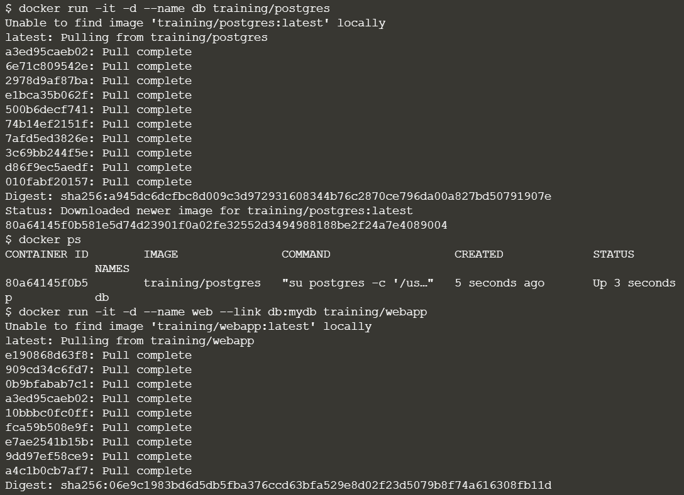



Take a bash terminal in "web" container and Test container linking by doing a ping to "mydb"

$ docker exec -it web bash

And then run

# ping mydb

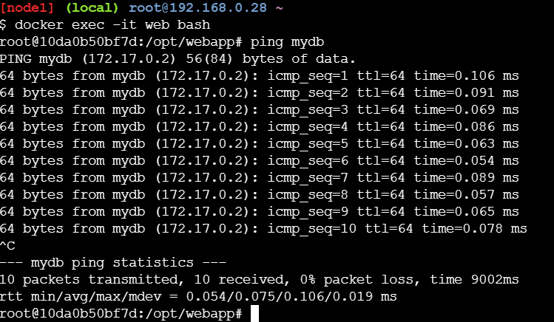

Create Swarm

